**Trees**

* **Trees Introduction:**

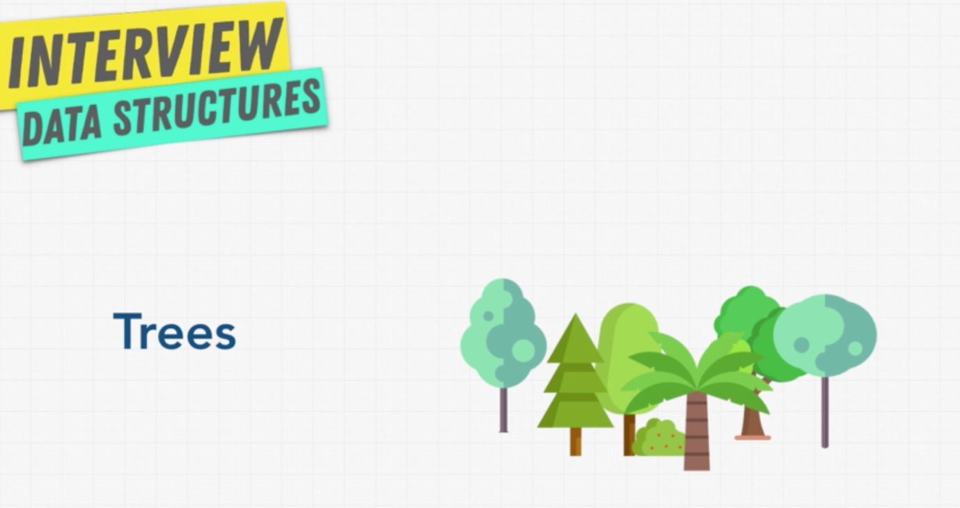

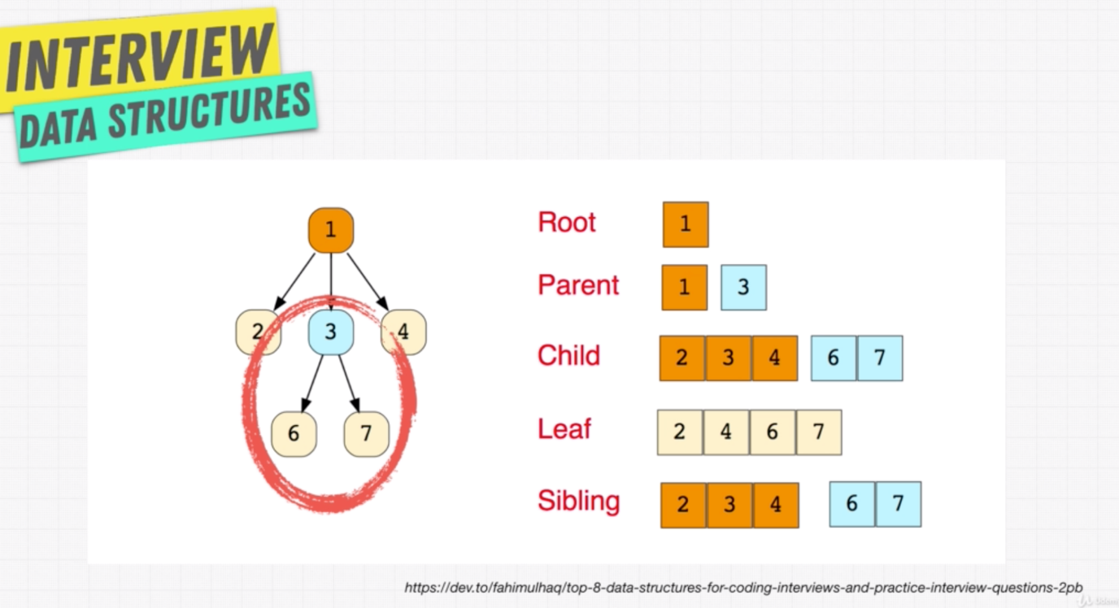

Parent and child relationship is uni-directional.

Real world examples of tree data structure:

Browser uses DOM tree to read the data to present it on the screen.

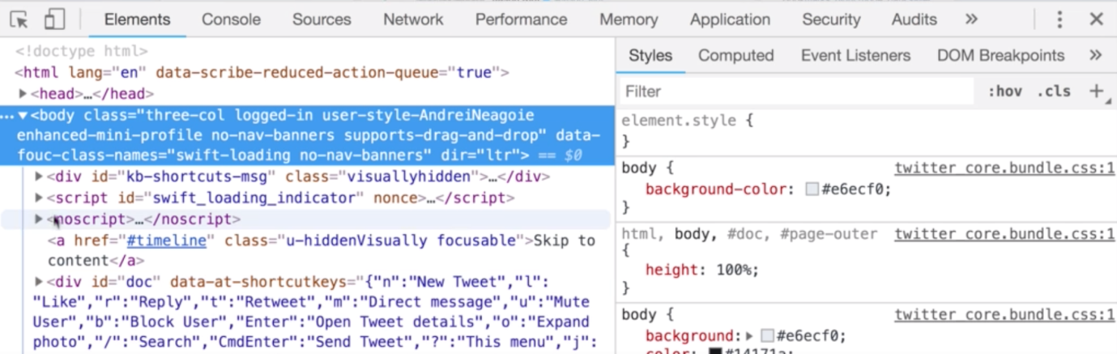

Chess game uses tree to decide the next move.

Abstract Syntax Tree:

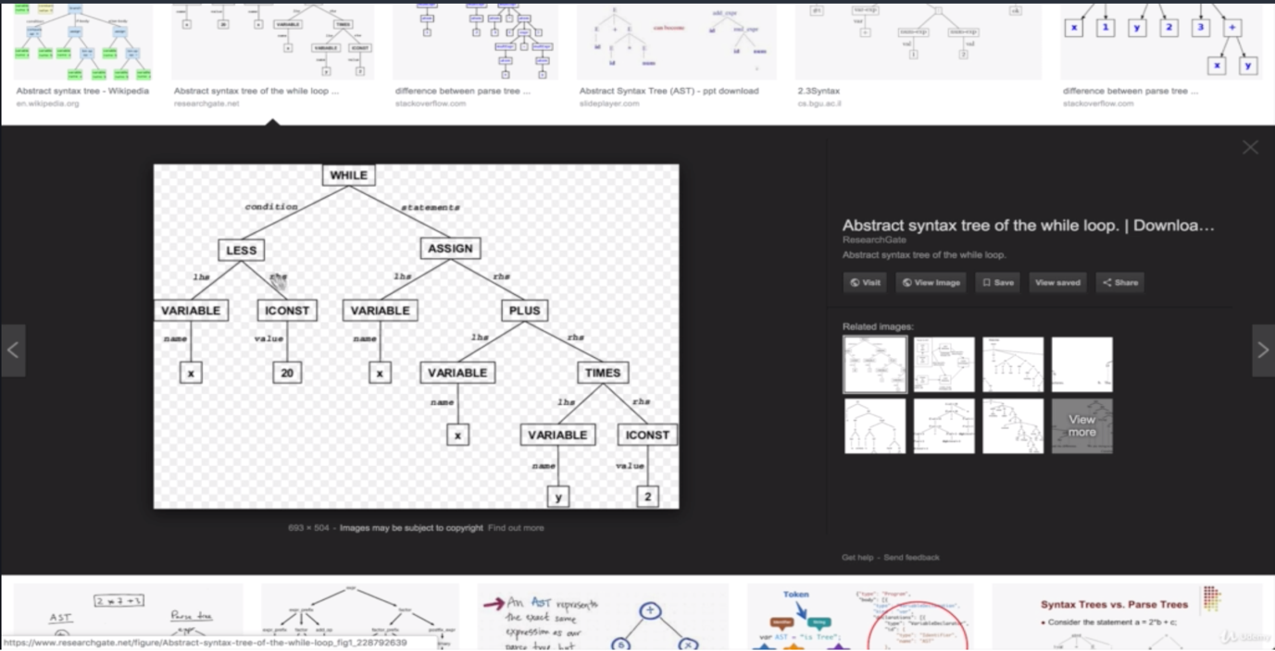

Linked list is one kind of tree:

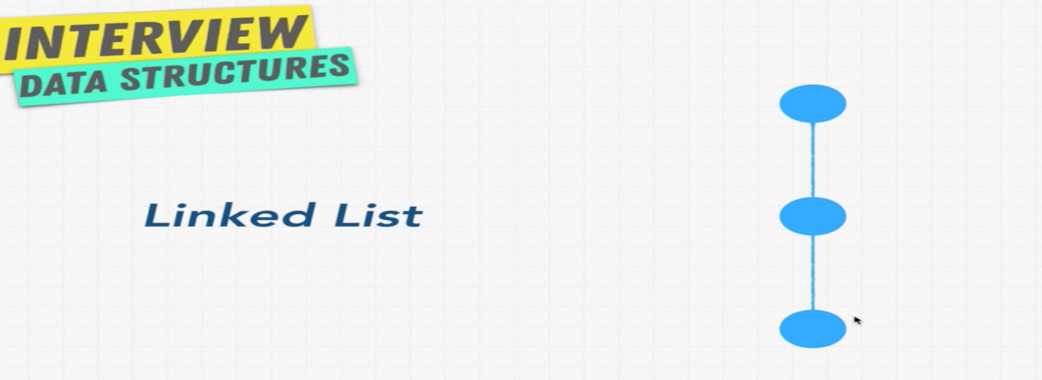

As like real trees there are different types of tree data structures are available.

* **Binary Trees:**

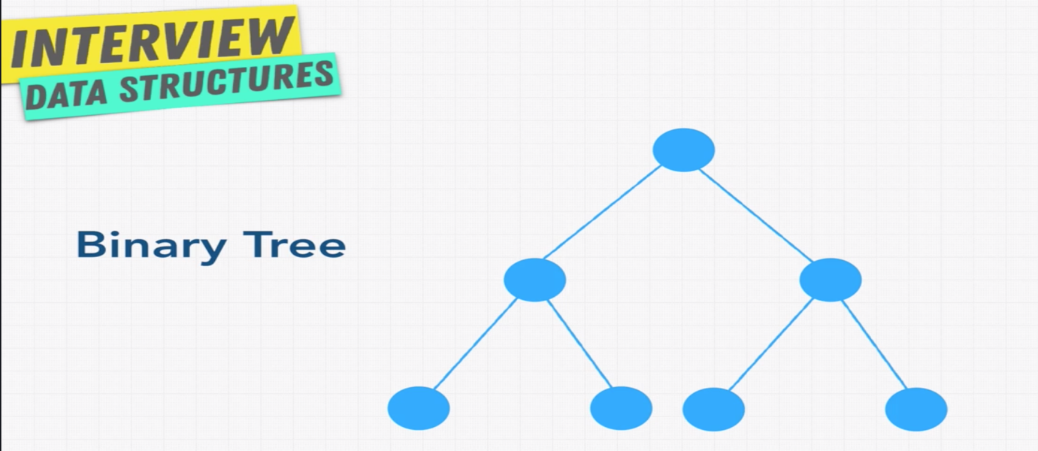

This is normal tree with following restrictions:

Each node will have 0, 1, or 2 nodes.

Each child will have only one parent.

Each node represents a state.

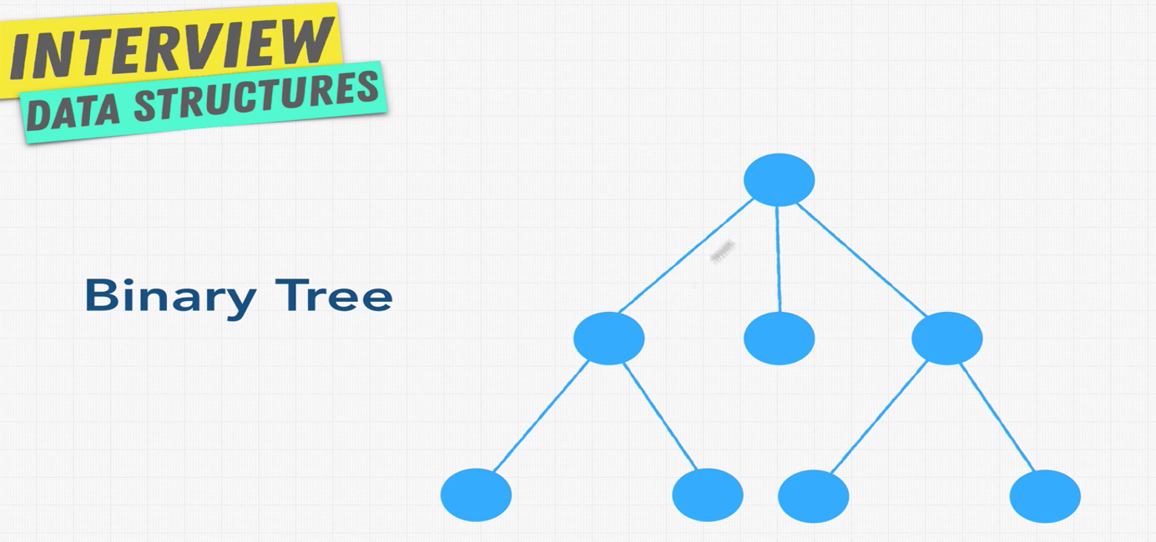

This is not a binary tree as of it node has a three children.

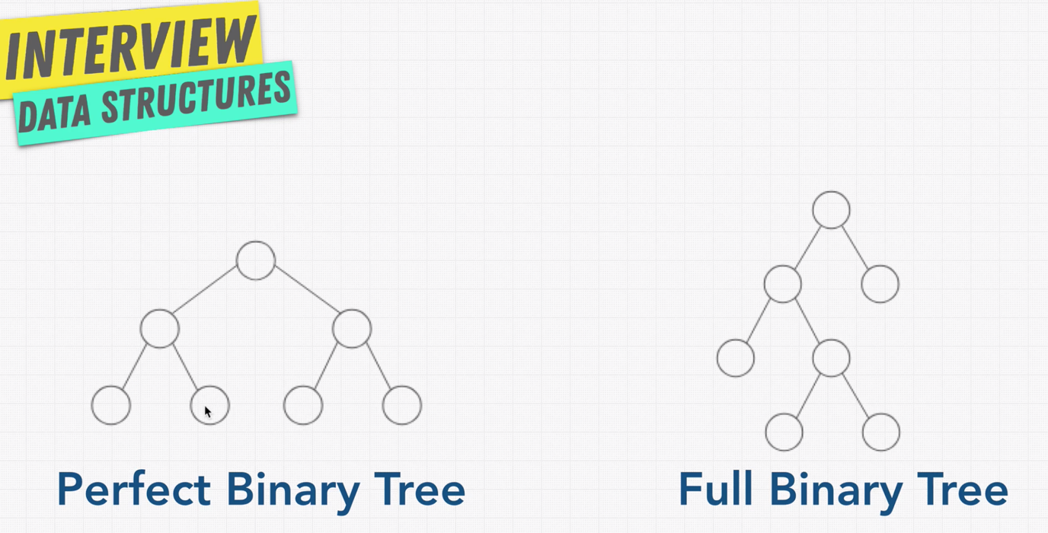

Perfect Binary Tree:

Everything filled in.

All the leaf node are filled, and there no node which has only one child.

A node either has a zero children or two children. And also the bottom layer of the tree is completely full.

Perfect Binary Tree is really efficient. If the Binary tree is perfect, it has two interesting properties:

Number of nodes in each level doubles as we move down the tree.

Number of nodes on the last level is equal to the sum of the number of nodes on all the other levels + 1

Full Binary Tree:

A node has either a zero or two children never one children.

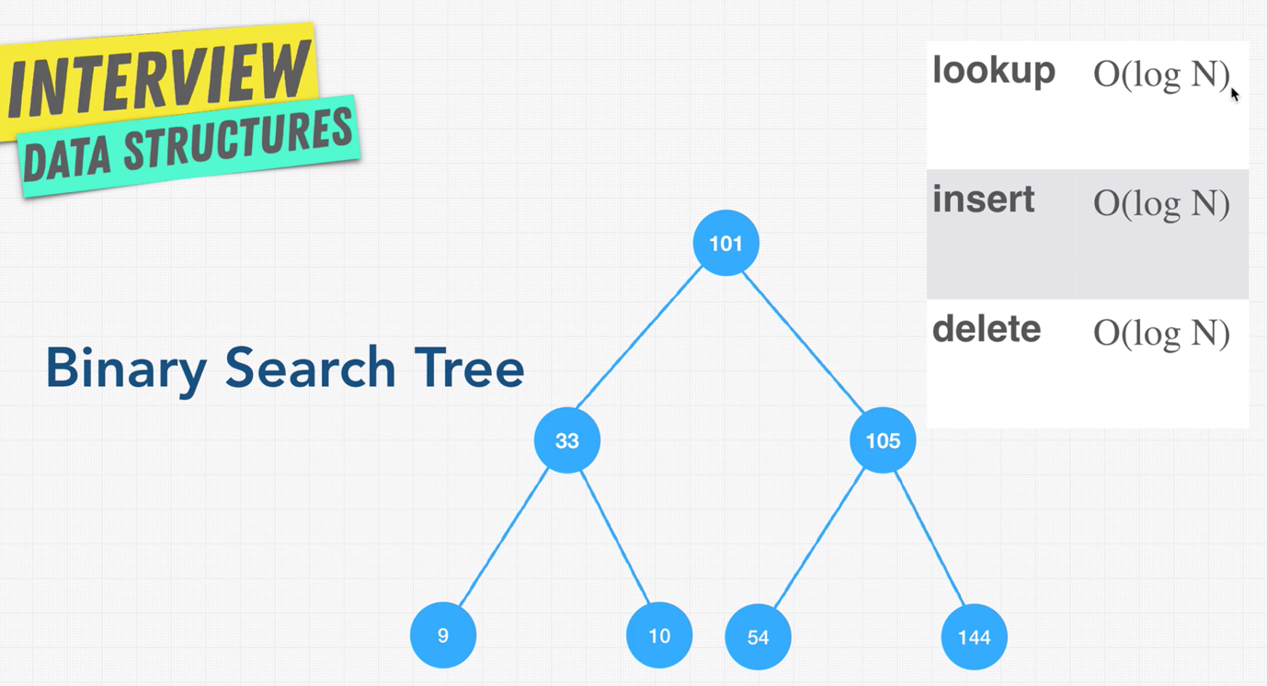

* **O(log n):**

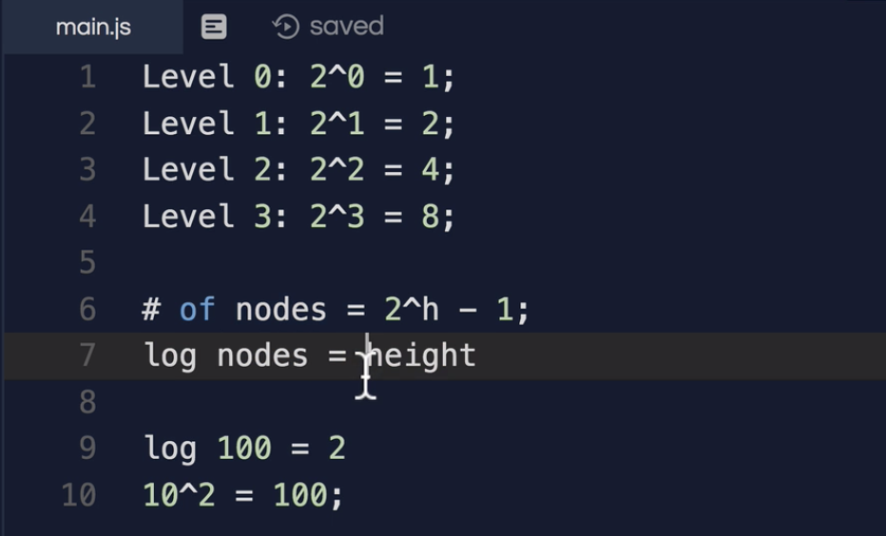

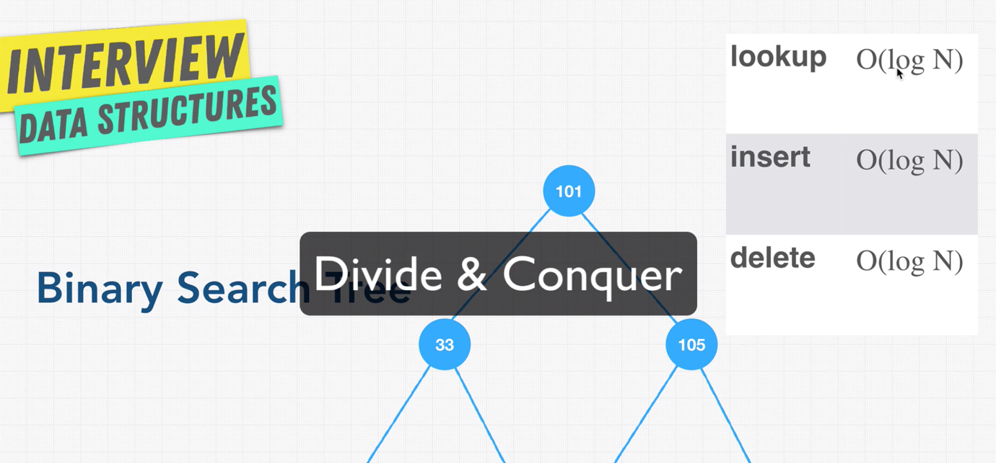

* **Binary Search Tree:**

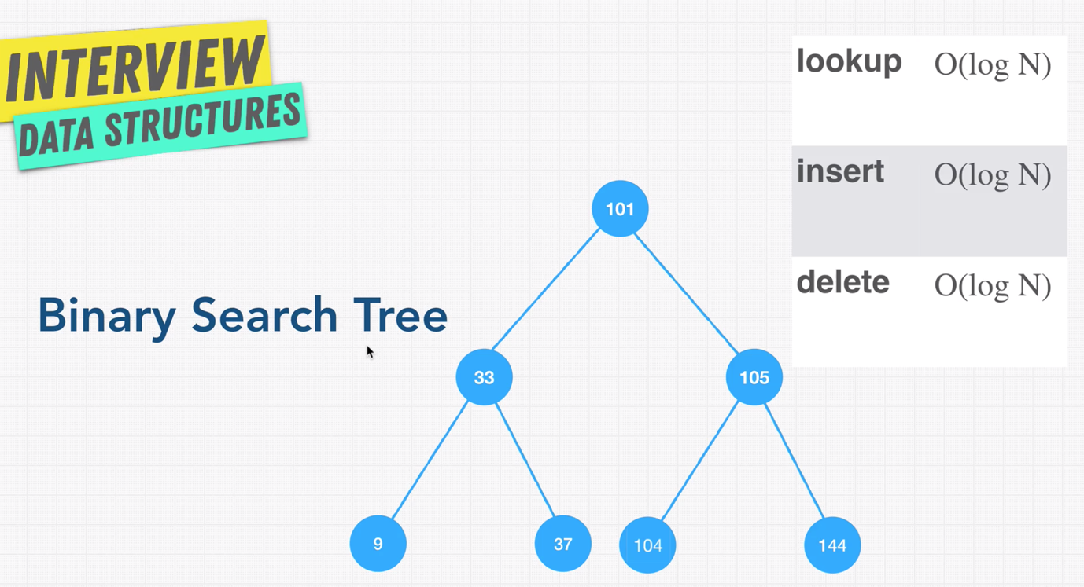

Binary search trees are sub set of tree.

Binary search trees are better for searching.

When you go through right side of the tree the node value keep increases. When you go through the left side of the node, it will keep decreases.

A node can only have up to two children, because it is a binary tree.

Search will be easier in binary tree. Let’s say you want to search value 37 in the tree.

Step-1: Is 37 less than 101? Yes, then go left.

Step-2: Is 37 less that 33? No, then go right.

Step-3: Found the value.

With Binary tree we don’t have to iterate in linear fashion like arrays.

For delete operation, we have to find the node and post that we have to decide which node will replace the deleted node (whether the left one or right one).

* **Balanced VS Unbalanced BST:**

Let’s say we have a BST like shown below, which has most of the nodes on the right and minimal nodes on left.

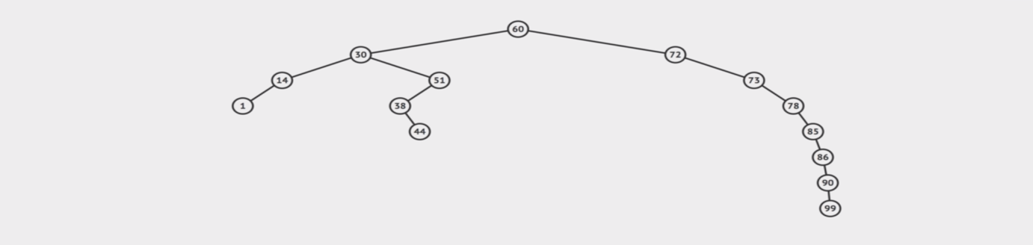

In given scenario if we don’t have the left side at all, the BST will look like a Linked List.

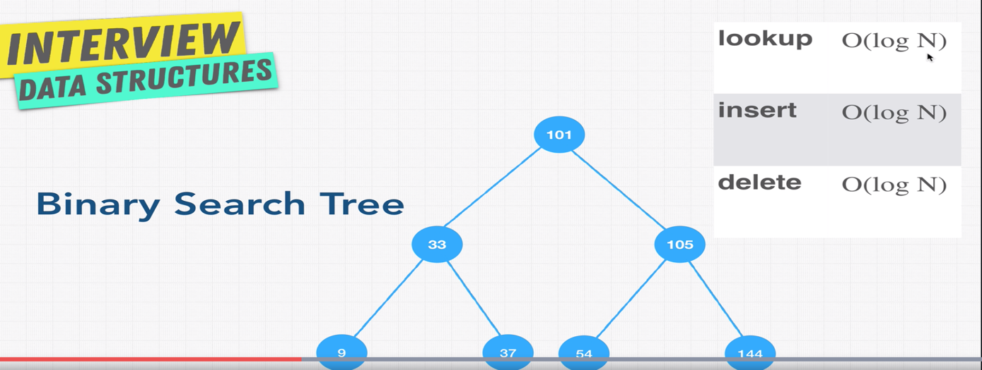

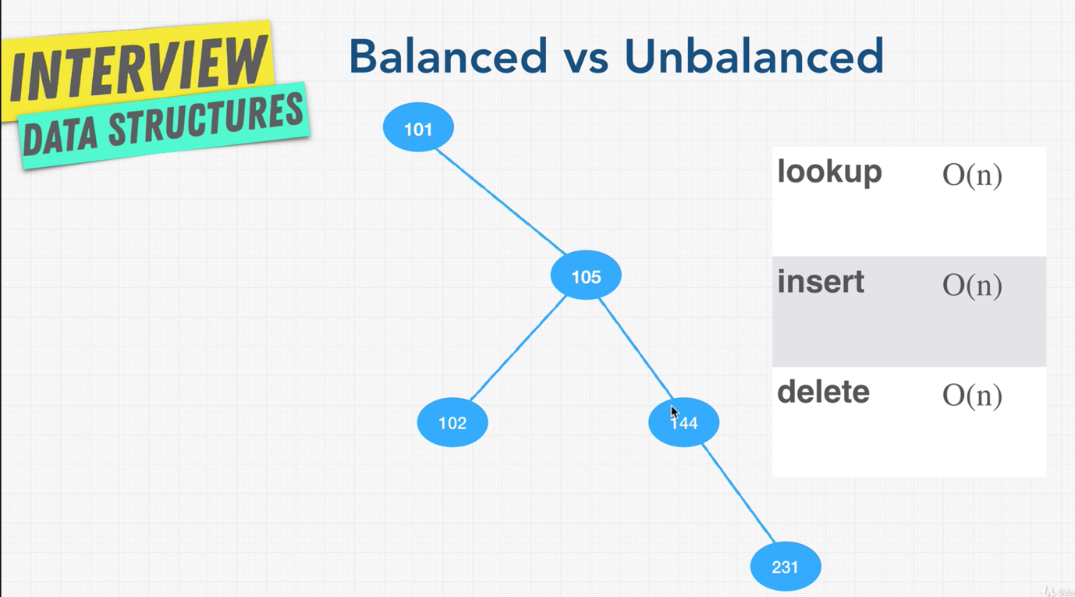

Common interview question on BST, why unbalanced BST are bad?

Because it takes O(n) for lookup, insert and delete when compared to Balanced BST O(log n).

* **Pros & Cons of BST:**

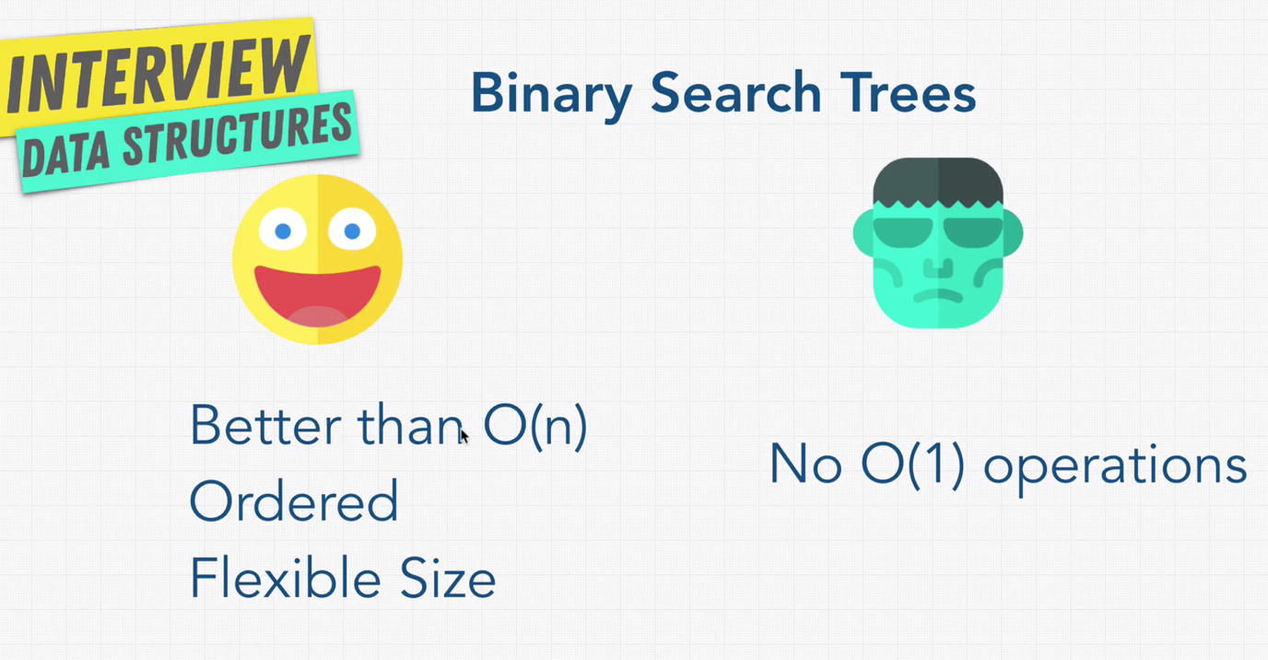

* **Tries:**

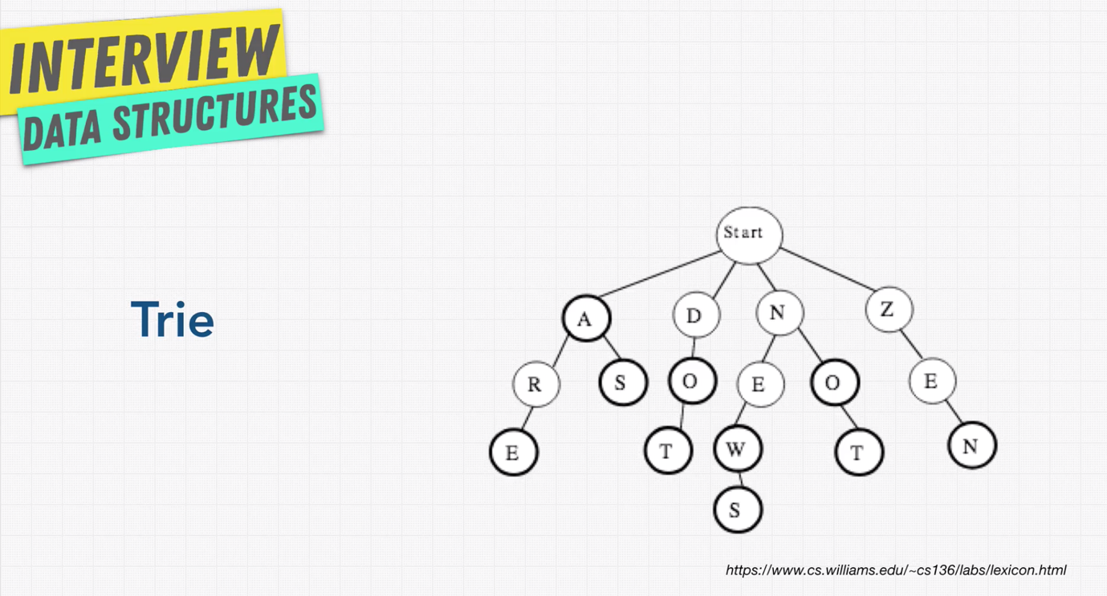

Trie is a special tree mostly used in searching.

Tries are used in finding the list of words for the given character.

Tries are used in auto completion (In google whenever we type it will suggestion).

